

**A Project Report On**

AUTOMATION TESTING ON DOMINO’S WEBSITE

**Pushpanjali Ghadage**

**Batch: 5334**

**Course: School of Coding-Certified Software Test Engineer**

**Under the Guidance of, Priyanka Desale**

**(Technical Trainer) EduBridge**

**INTRODUCTION**

This Project aims to do overall testing like functional testing, GUI testing on website to check quality of application. It helps to improve quality of website and saves time for manually doing this testing. In this project our main focus is to check functionalities available on website. Also, it includes title check and all links count with their workingstatus.

**SOFTWARE REQUIREMENTS**

* Operating System: Windows10
* Browser: Latest version ofFirefox
* IDE: EclipseIDE
* Automation Tool: Selenium WebDriver
* Front-end: Java

**TC01- Launch the browser and open New Website.**

System.*setProperty*("webdriver.gecko.driver", "C:\\Users\\HI\\Desktop\\Seleniun er.exe");

WebDriver w = **new**FirefoxDriver();

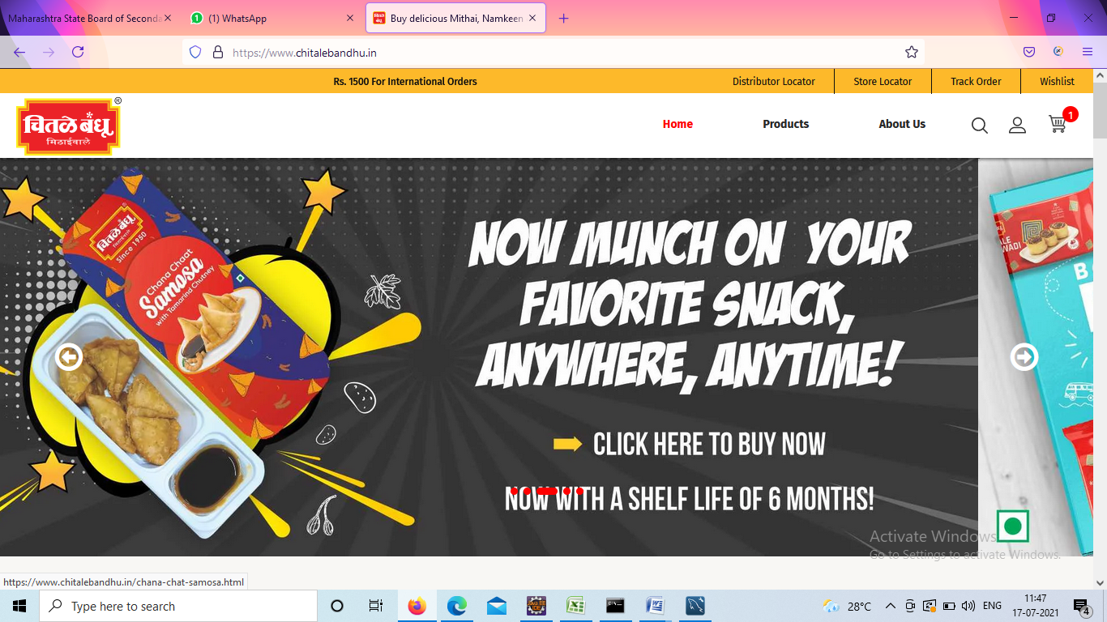 w.get("https://www.chitalebandhu.in/");

**TC02- Launch the browser and get title.**

System.*setProperty*("webdriver.gecko.driver", "C:\\Users\\HI\\Desktop\\Seleniun jar\\GeckoDriver.exe");

WebDriver w = **new**FirefoxDriver();

w.get("https://www.chitalebandhu.in/");

w.getTitle();

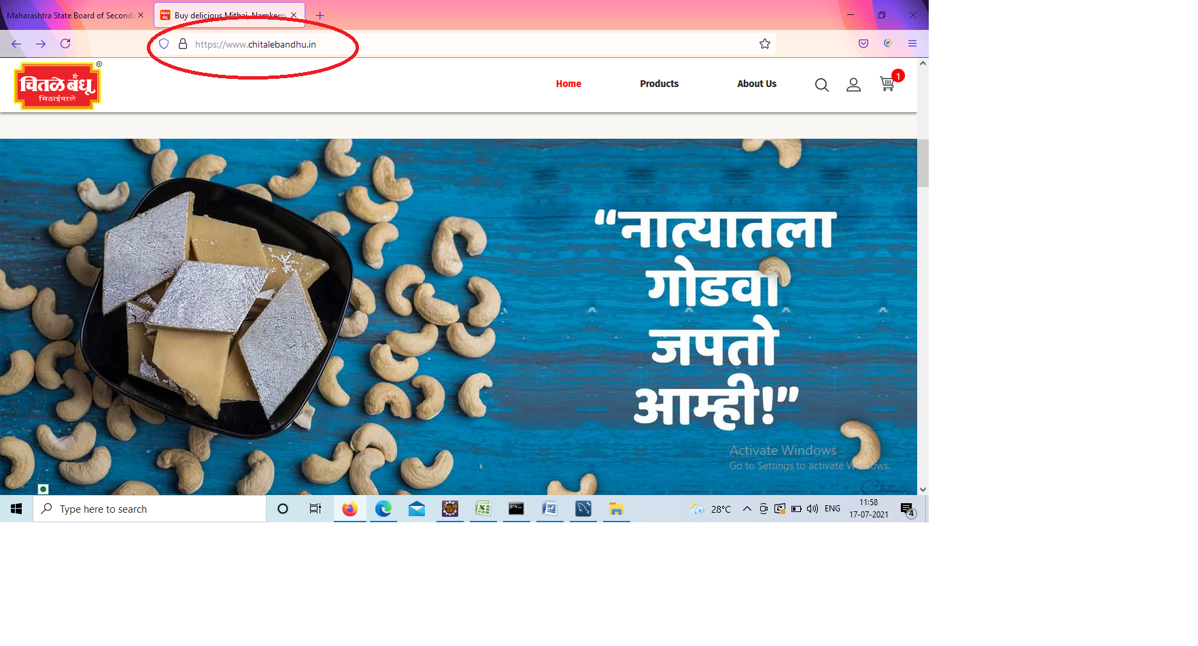

**TC03- check the functionality of distributor option from home page**

w.findElement(By.*xpath*("/html/body/div[2]/header/div[1]/div/div/ul/li[1]/a")).click(); //click on distributor locator

w.findElement(By.*id*("address")).sendKeys("pune");

Select s= **new** Select(w.findElement(By.*id*("radiusSelect")));

s.selectByIndex(2);

w.findElement(By.*xpath*("/html/body/div[2]/main/div[3]/div/div[4]/form/div/div/button/span/span")).click();

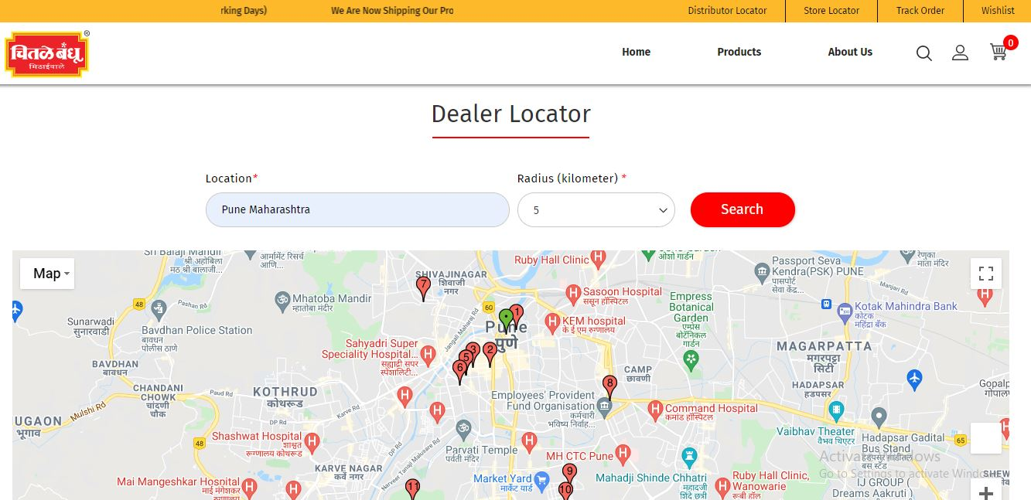

**TC04- check the functionality of Store locator from home page**

w.findElement(By.*xpath*("/html/body/div[2]/header/div[1]/div/div/ul/li[2]/a")).click();

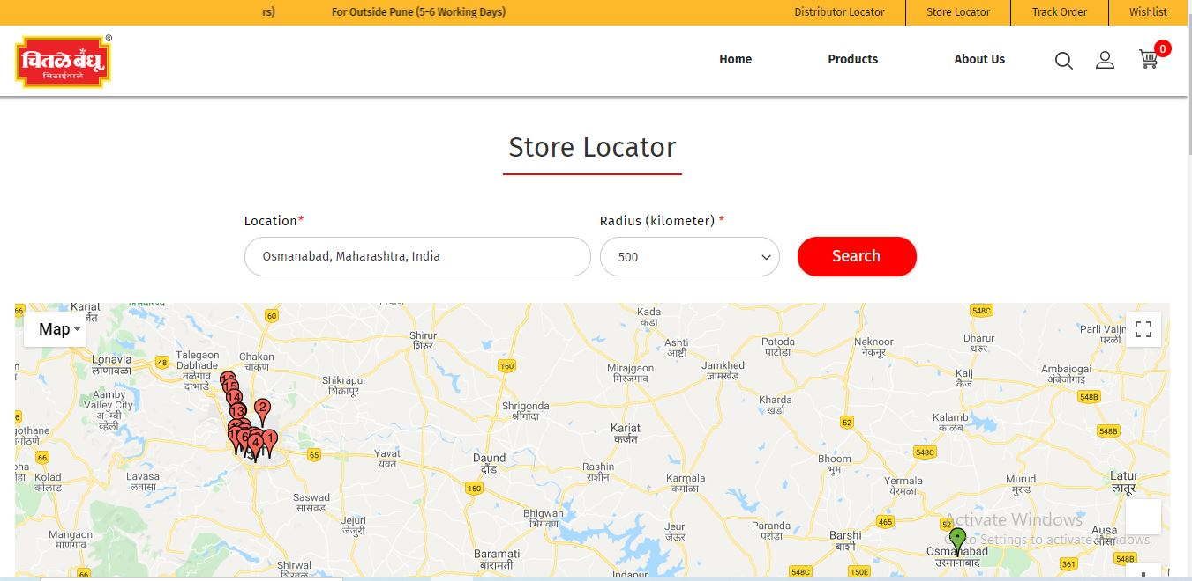

**TC05- check the functionality of distributor option from home page pass the values using send key**

w.findElement(By.*xpath*("/html/body/div[2]/header/div[1]/div/div/ul/li[2]/a")).click();

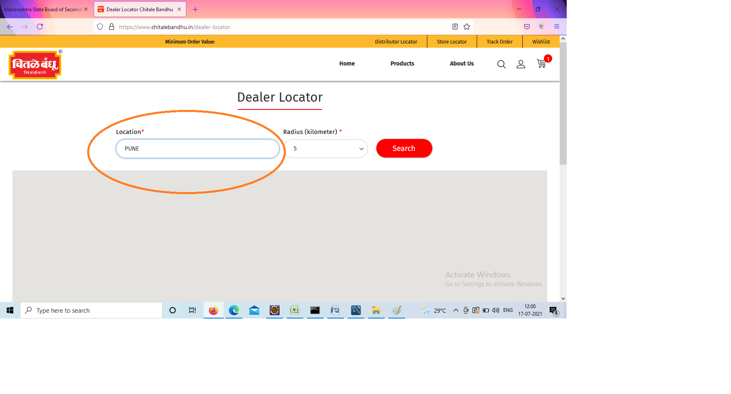w.findElement(By.*id*("address")).sendKeys("Osmanabad");

**TC06- check the functionality of distributor option from home page select the values using select**

Select s1 = **new** Select(w.findElement(By.*id*("radiusSelect")));

s1.selectByValue("10");

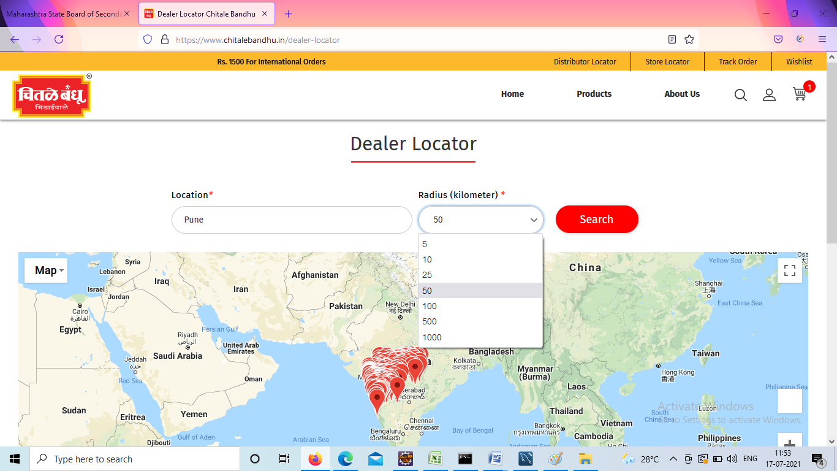

**TC07- check the functionality of Store locator using alert**

w.findElement(By.*xpath*("/html/body/div[2]/main/div[3]/div/div[4]/form/div/div/button/span/span")).click();

Thread.*sleep*(3000);

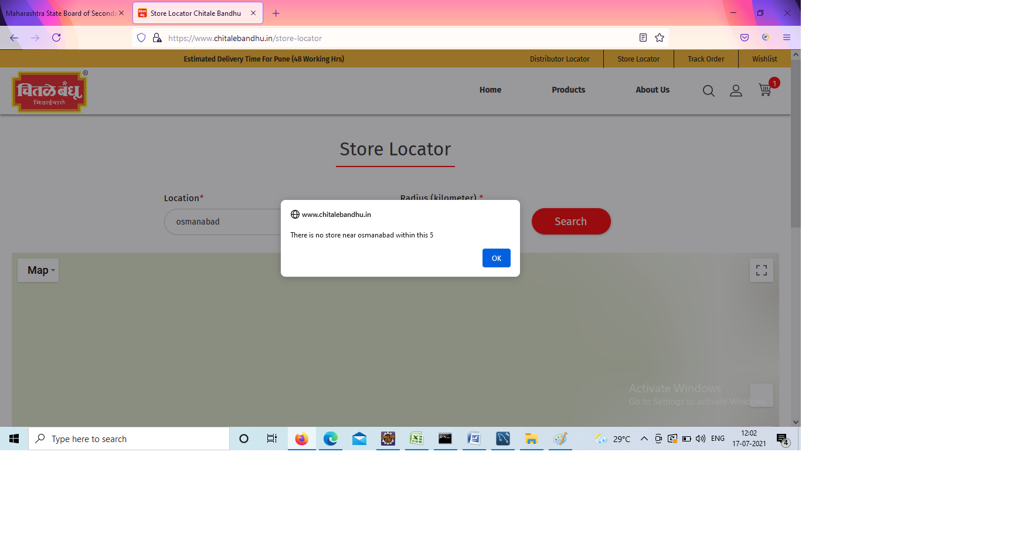 w.switchTo().alert().accept();

**TC08- check the functionality of Track Order**

w.findElement(By.*xpath*("/html/body/div[2]/header/div[1]/div/div/ul/li[3]/a")).click();

w.findElement(By.*name*("login[username]")).sendKeys("mahi@gil.com");

w.findElement(By.*name*("login[password]")).sendKeys("1256");

w.findElement(By.*id*("send2")).click(); //new login user

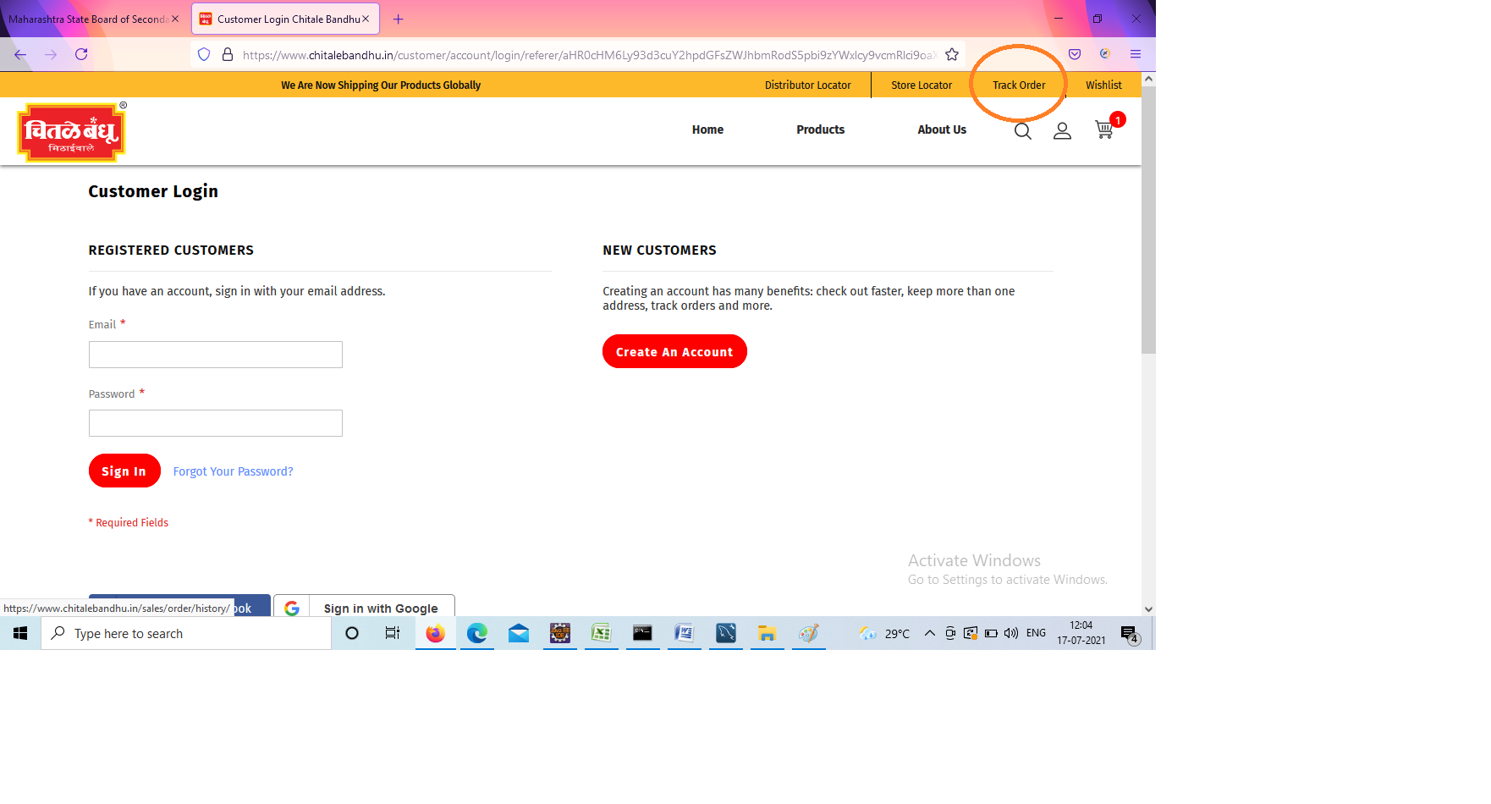 w.navigate().back();

**TC09- Click the functionality New login user**

w.findElement(By.*id*("send2")).click(); //new login user

w.navigate().back();

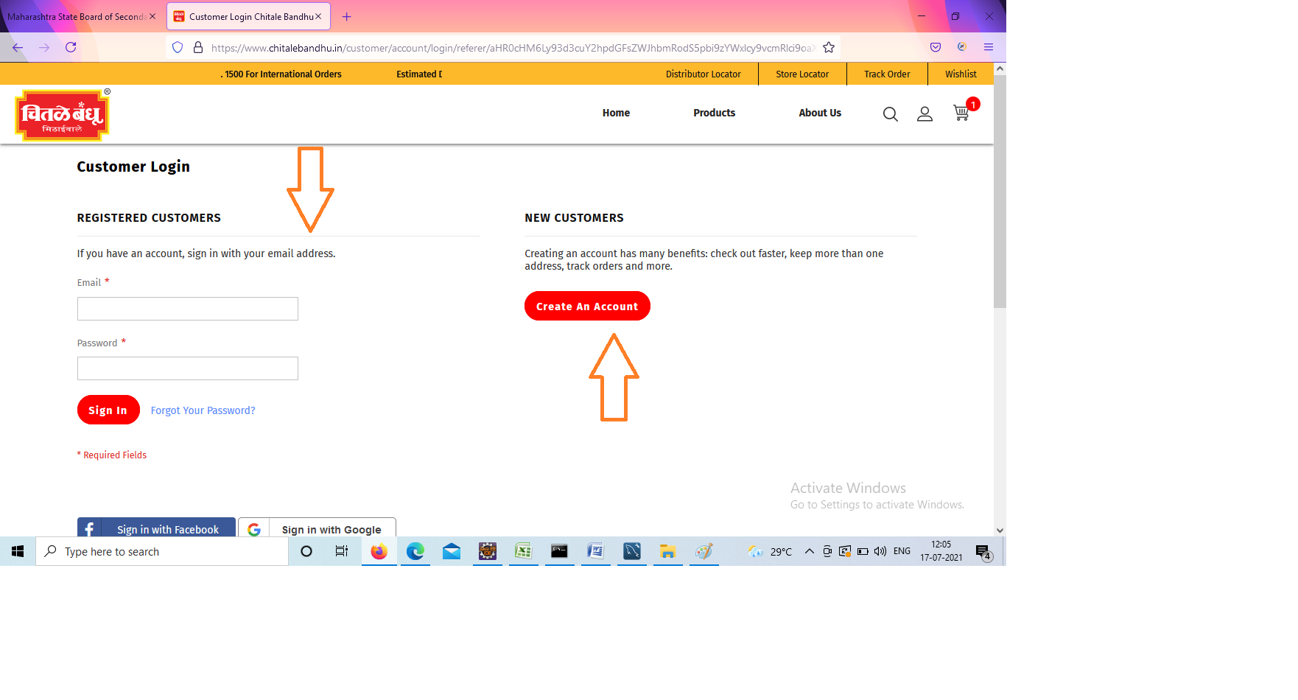

**TC10- Check the functionality and Fill the form New login user**

w.findElement(By.*xpath*("//*[@id=\"maincontent\"]/div[3]/div/div[4]/div[2]/div[2]/div/div/a")).click();

w.findElement(By.*xpath*("//form[@id='form-validate']//fieldset[@class='fieldset create info']//div[@class='field field-name-firstname required']//div[@class='control']//input[@id='firstname']")).sendKeys("Mahi123");

w.findElement(By.*xpath*("//form[@id='form-validate']//fieldset[@class='fieldset create info']//div[@class='field field-name-lastname required']//div[@class='control']//input[@id='lastname']")).sendKeys("Mahi123");

w.findElement(By.*xpath*("//div[@class='field required']//div[@class='control']//input[@id='email_address']")).sendKeys("mahi@123.gmail.com"); w.findElement(By.*xpath*("//*[@id=\"password\"]")).sendKeys("M@hi12345");

w.findElement(By.*xpath*("//input[@id='password-confirmation']")).sendKeys("M@hi12345");

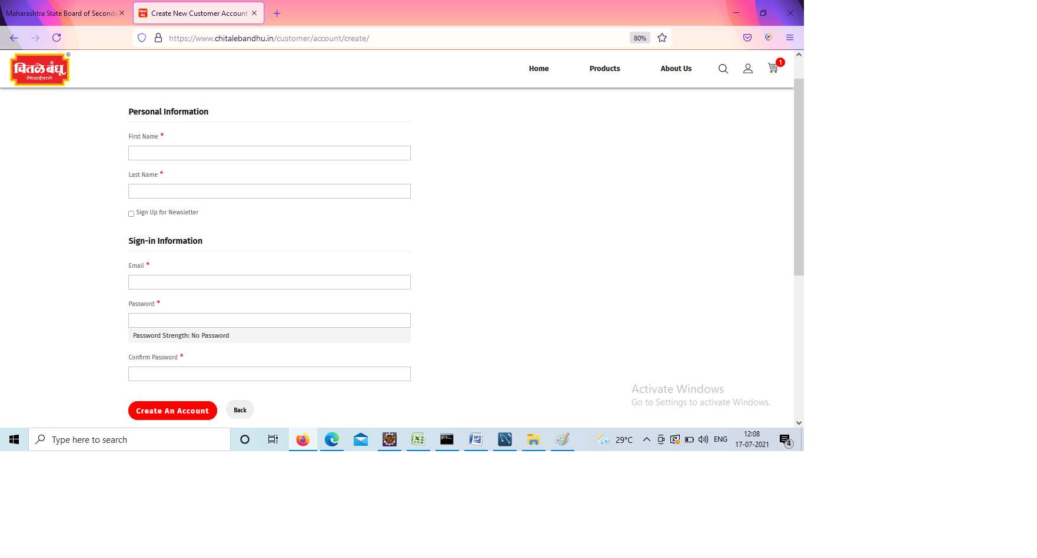 w.findElement(By.*xpath*("//form[@id='form-validate']//div[@class='actions-toolbar']//div[@class='primary']//button[@type='submit']")).click();

**TC11- Click the functionality New login user**

w.findElement(By.xpath("/html/body/div[2]/header/div[2]/ul[1]/li[2]/a")).click();

w.findElement(By.name("username")).sendKeys("mahi@22.gmail.com");

w.findElement(By.name("password")).sendKeys("M@hi12345");

w.findElement(By.xpath("//button[@id='bnt-social-login-authentication']")).click();

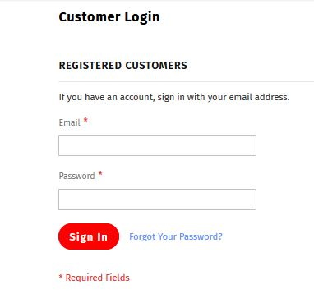

**TC12 – To check the functionality of About us option**

w.findElement(By.*xpath*("/html/body/div[2]/header/div[2]/div[3]/ul/li[3]/a/span")).click();//about us

JavascriptExecutorjs= (JavascriptExecutor) w;

//js.executeScript("window.scrollTo(0,document.body.scrollHeight)", "");

Thread.*sleep*(3000);

js.executeScript("window.scrollBy(0,5000)","");

System.***out***.println("Page Down");

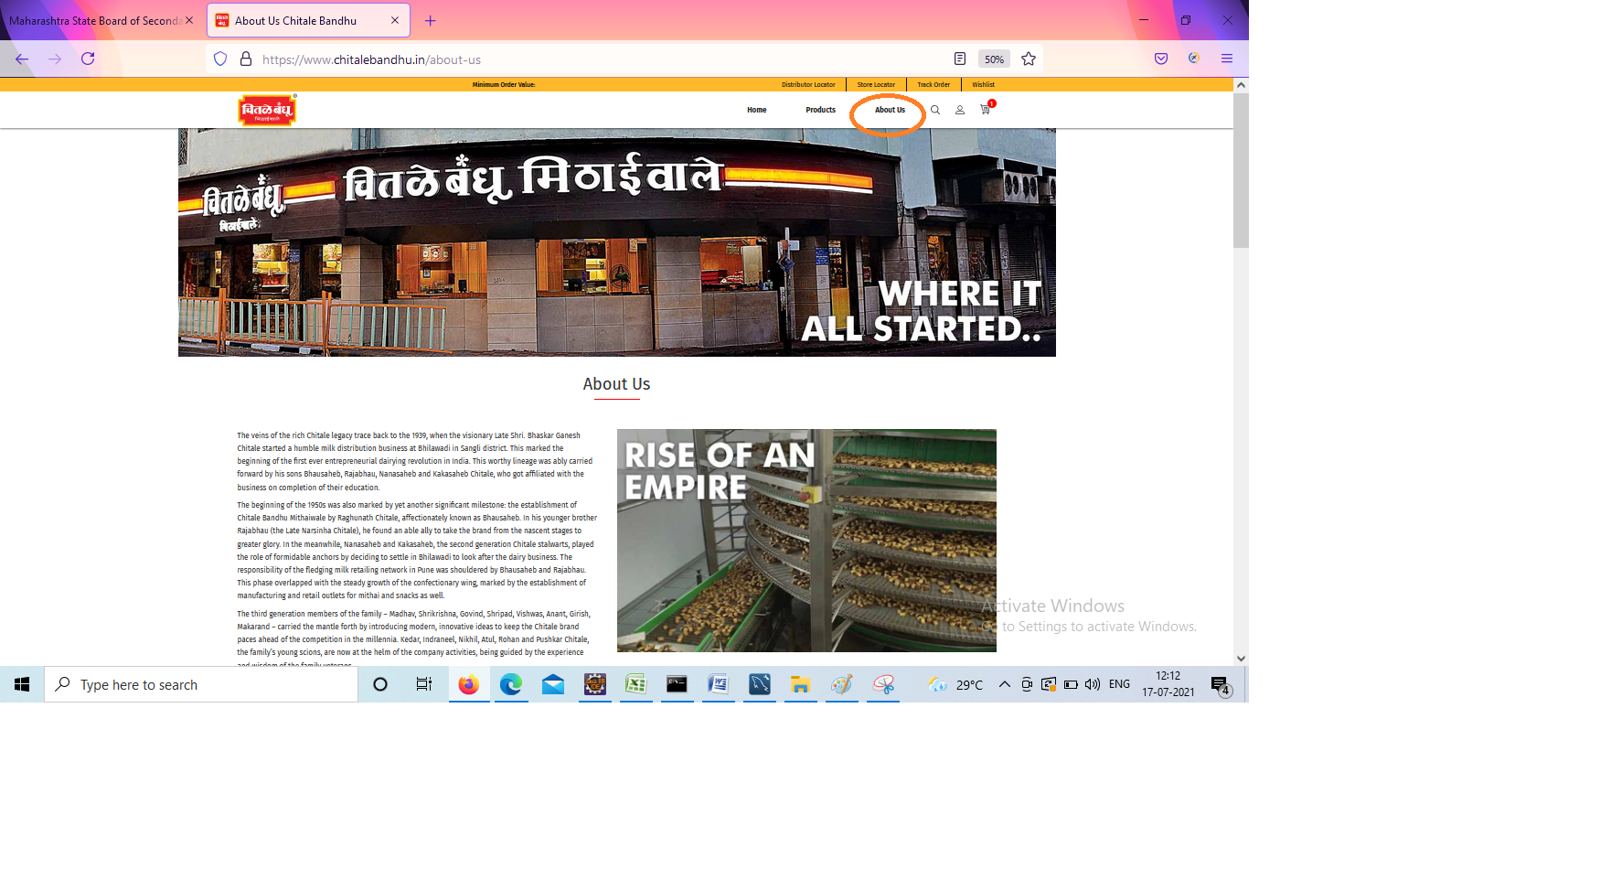

**TC13- To check the functionality of Contact us option**

w.findElement(By.*xpath*("/html/body/div[2]/footer/div[3]/div/div[2]/ul/li[3]/a")).click();

w.findElement(By.*xpath*("//*[@id=\"loffield_c11\"]")).sendKeys("1mahi22");

w.findElement(By.*xpath*("//*[@id=\"loffield_c41\"]")).sendKeys("124567890");

w.findElement(By.*xpath*("//*[@id=\"loffield_c21\"]")).sendKeys("mahi22@mil.com");

w.findElement(By.*xpath*("//*[@id=\"loffield_c71\"]")).sendKeys("Submit defect report");

w.findElement(By.*xpath*("//*[@id=\"loffield_c31\"]")).sendKeys("Contact me i will explain all the defects in your website");

w.findElement(By.*xpath*("/html/body/div[2]/main/div[3]/div/div[4]/div/form/div[2]/div/button")).click();

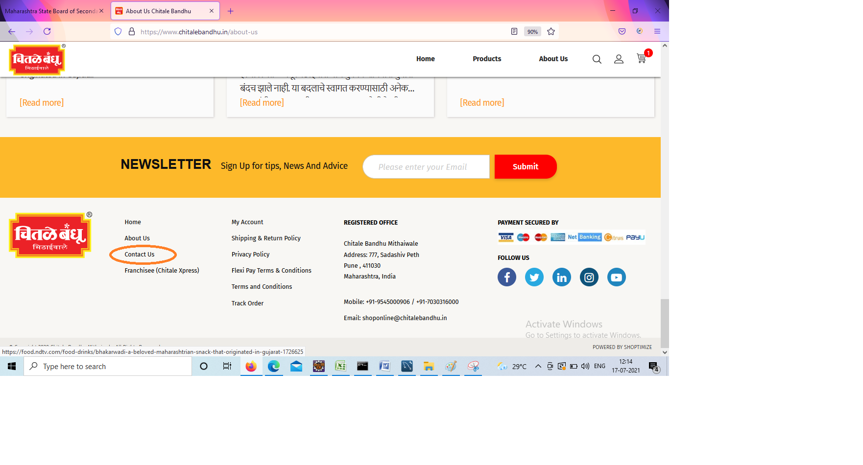 Thread.*sleep*(3000);

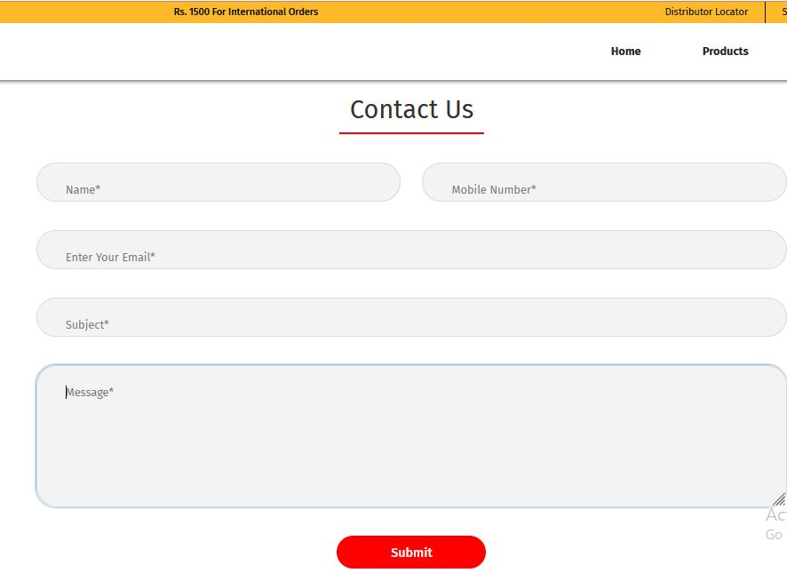

**TC14-To check the functionality of Sign Up for tips and Advice**

w.findElement(By.*xpath*("//*[@id=\"newsletter\"]")).sendKeys("mahi%@dd.com");//

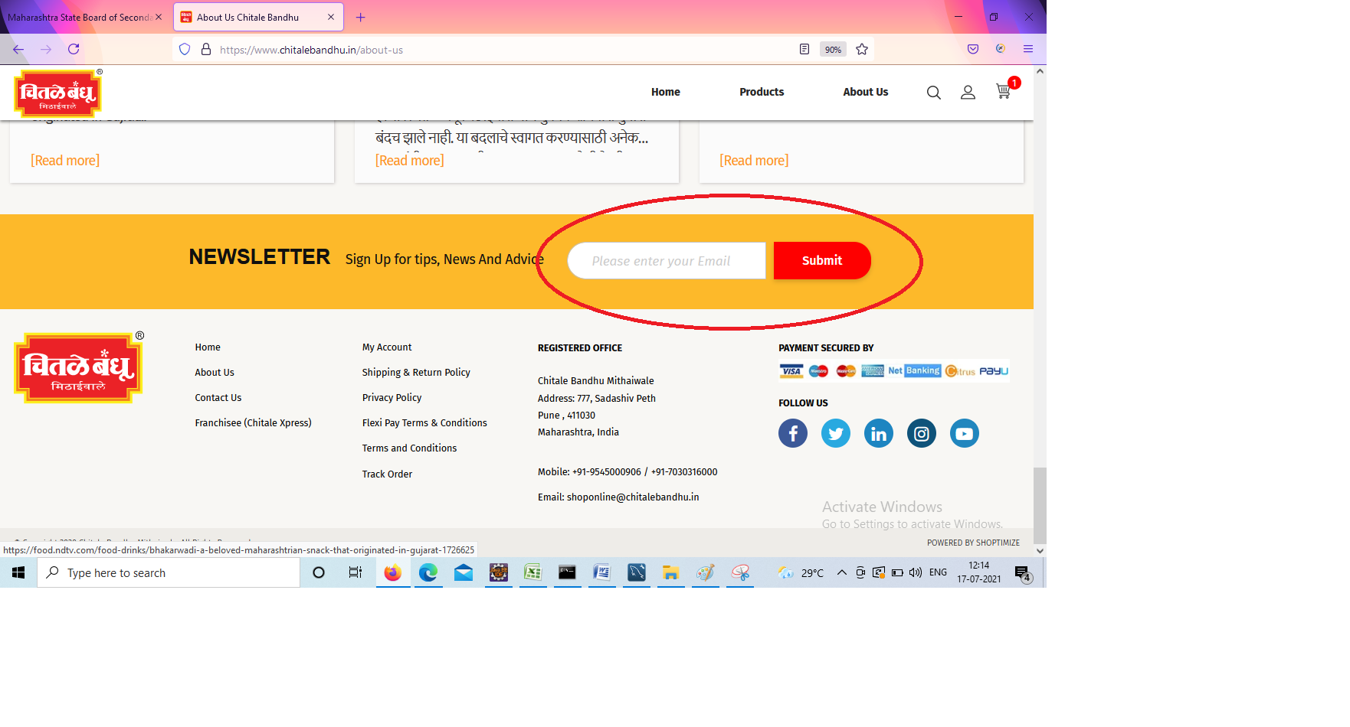 w.findElement(By.*xpath*("/html/body/div[2]/footer/div[2]/div/div/div[2]/form/div[2]/button")).click();

**TC15-To check the functionality of back button click home**

w.findElement(By.*xpath*("/html/body/div[2]/header/div[2]/div[3]/ul/li[1]/a/span")).click();//HOME

JavascriptExecutorjs2= (JavascriptExecutor) w;

js2.executeScript("window.scrollBy(0,550)","");

 w.navigate().back();

**TC16-To check the functionality of Milk products**

w.findElement(By.*xpath*("/html/body/div[2]/main/div[3]/div/div[5]/div/div[1]/a[1]/img")).click();// milk product

JavascriptExecutorj= (JavascriptExecutor) w;

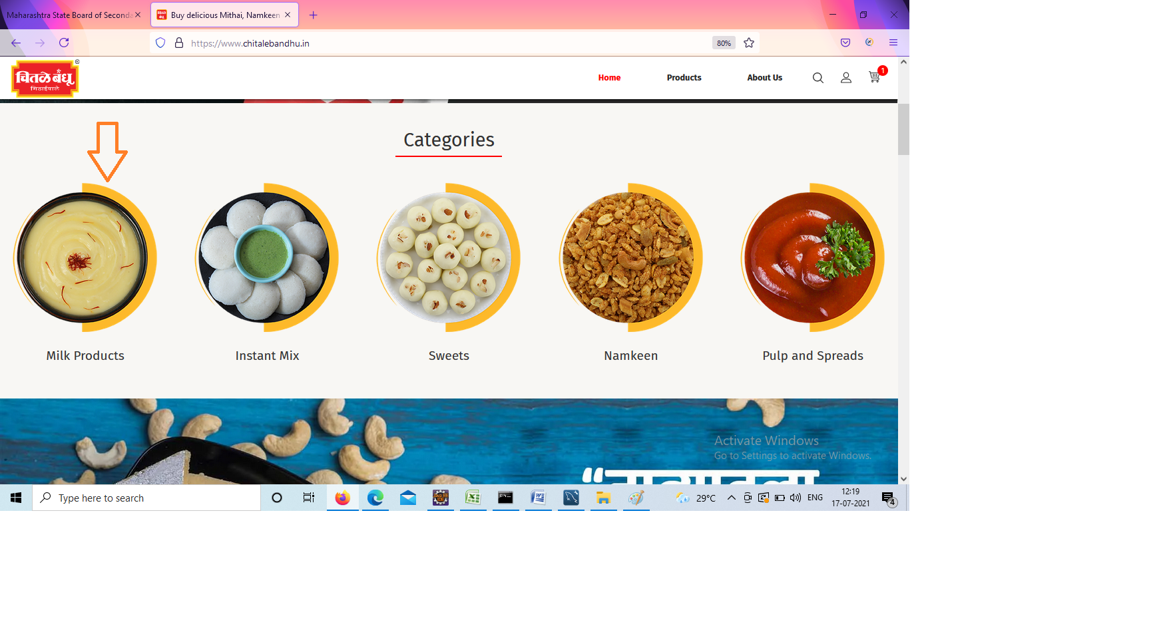

**TC17-To check the functionality of Milk products scroll down and scroll up**

JavascriptExecutorj= (JavascriptExecutor) w;

//js.executeScript("window.scrollTo(0,document.body.scrollHeight)", "");

Thread.*sleep*(3000);

j.executeScript("window.scrollBy(0,2000)","");

System.***out***.println("Page Down");

Thread.*sleep*(3000);

j.executeScript("window.scrollBy(0,-2000)","");

System.***out***.println("Page UP");

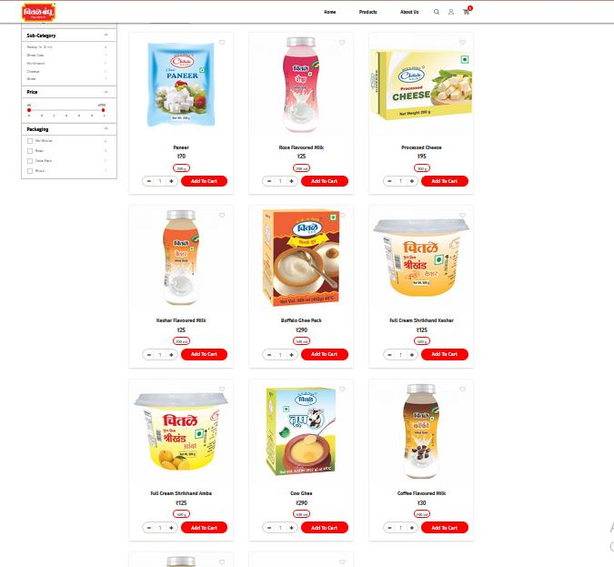 w.navigate().back();

**TC18-To check the functionality of Redimix and Instant scroll down and scroll up**

w.findElement(By.*xpath*("/html/body/div[2]/main/div[3]/div/div[5]/div/div[2]/a[1]/img")).click();//Mix

JavascriptExecutorj1= (JavascriptExecutor) w;

//js.executeScript("window.scrollTo(0,document.body.scrollHeight)", "");

Thread.*sleep*(3000);

j1.executeScript("window.scrollBy(0,2000)","");

System.***out***.println("Page Down");

Thread.*sleep*(3000);

j1.executeScript("window.scrollBy(0,-2000)","");

System.***out***.println("Page UP");

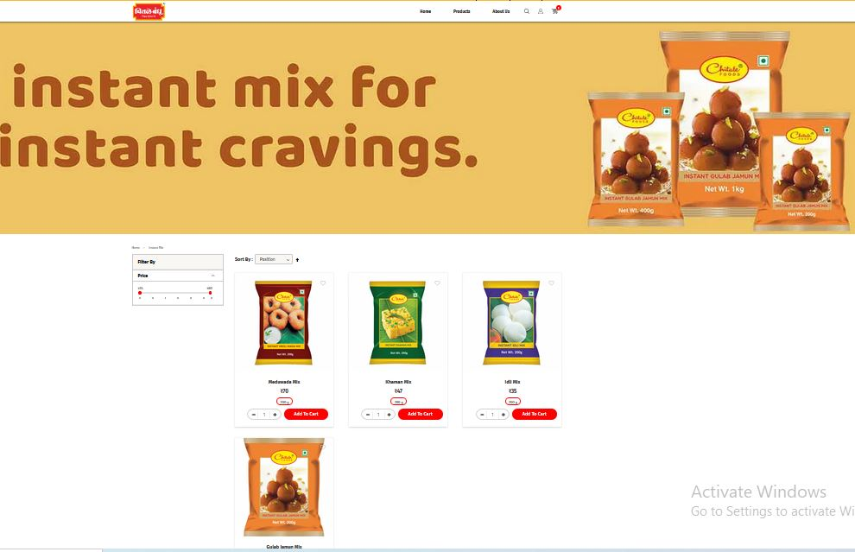 w.navigate().back();

**TC19-To check the functionality of Sweets scroll down and scroll up**

w.findElement(By.*xpath*("/html/body/div[2]/main/div[3]/div/div[5]/div/div[3]/a[1]/img")).click();//Sweets

JavascriptExecutorj2= (JavascriptExecutor) w;

//js.executeScript("window.scrollTo(0,document.body.scrollHeight)", "");

Thread.*sleep*(3000);

j2.executeScript("window.scrollBy(0,2000)","");

System.***out***.println("Page Down");

Thread.*sleep*(3000);

j2.executeScript("window.scrollBy(0,-2000)","");

System.***out***.println("Page UP");

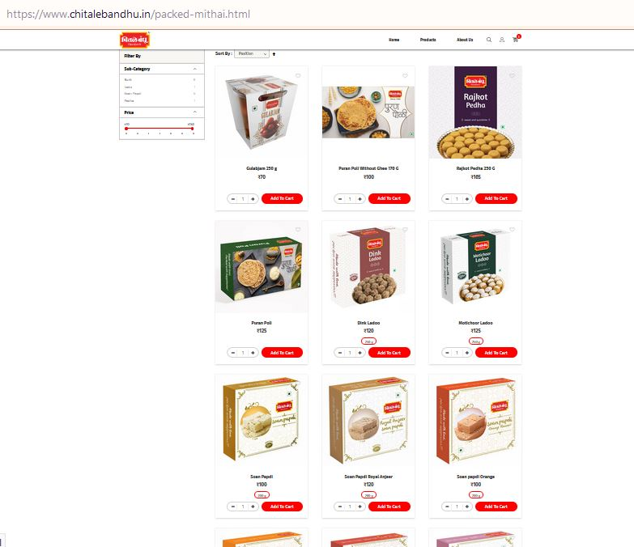 w.navigate().back();

**TC20-To check the functionality of Namkeen scroll down and scroll up**

w.findElement(By.*xpath*("/html/body/div[2]/main/div[3]/div/div[5]/div/div[4]/a[1]/img")).click();//Namkeen

JavascriptExecutorj3= (JavascriptExecutor) w;

//js.executeScript("window.scrollTo(0,document.body.scrollHeight)", "");

Thread.*sleep*(3000);

j3.executeScript("window.scrollBy(0,2000)","");

System.***out***.println("Page Down");

Thread.*sleep*(3000);

j3.executeScript("window.scrollBy(0,-2000)","");

System.***out***.println("Page UP");

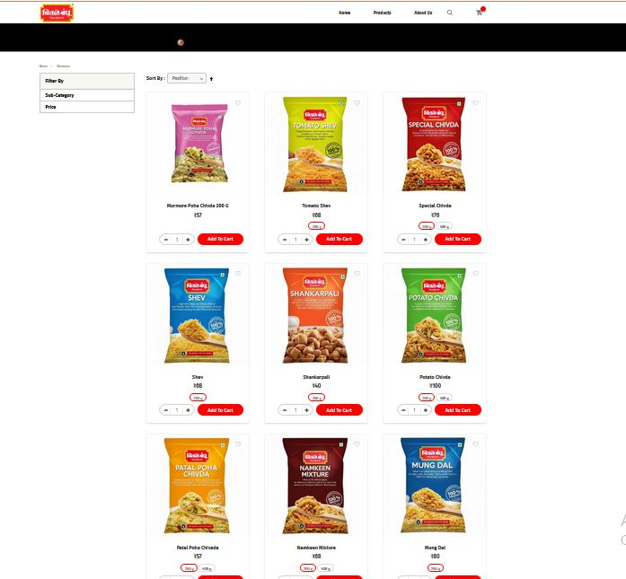 w.navigate().back();

**TC21-To check the functionality of Pulp and Spreads scroll down and scroll up**

w.findElement(By.*xpath*("/html/body/div[2]/main/div[3]/div/div[5]/div/div[5]/a[1]/img")).click();//Pulp

JavascriptExecutorj4= (JavascriptExecutor) w;

//js.executeScript("window.scrollTo(0,document.body.scrollHeight)", "");

Thread.*sleep*(3000);

j4.executeScript("window.scrollBy(0,2000)","");

System.***out***.println("Page Down");

Thread.*sleep*(3000);

j4.executeScript("window.scrollBy(0,-2000)","");

System.***out***.println("Page UP");

w.navigate().back();

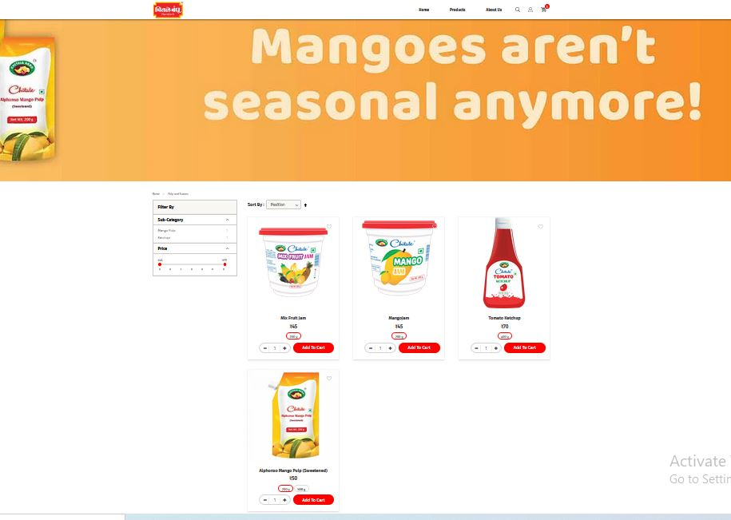

**TC22-To check the functionality of home and click milk product**

w.navigate().back();

w.findElement(By.*xpath*("/html/body/div[2]/main/div[3]/div/div[5]/div/div[1]/a[1]/img")).click();// milk product

JavascriptExecutorj5= (JavascriptExecutor) w;

//js.executeScript("window.scrollTo(0,document.body.scrollHeight)", "");

Thread.*sleep*(3000);

j5.executeScript("window.scrollBy(0,500)","");

**TC23-To check the functionality of filter option**

Select S1 = **new** Select(w.findElement(By.*id*("sorter")));

S1.selectByIndex(1);

Thread.*sleep*(3000);

Select S = **new** Select(w.findElement(By.*id*("sorter")));

S.selectByIndex(2);

Thread.*sleep*(3000);

Selects2 = **new**Select(w.findElement(By.*id*("sorter")));

s2.selectByIndex(3);

Thread.*sleep*(3000);

Selects2 = **new**Select(w.findElement(By.*id*("sorter")));

s2.selectByIndex(4);

Thread.*sleep*(3000);

Selects2 = **new**Select(w.findElement(By.*id*("sorter")));

s2.selectByIndex(5);

Thread.*sleep*(3000);

Selects2 = **new**Select(w.findElement(By.*id*("sorter")));

s2.selectByIndex(0);

Thread.*sleep*(3000);

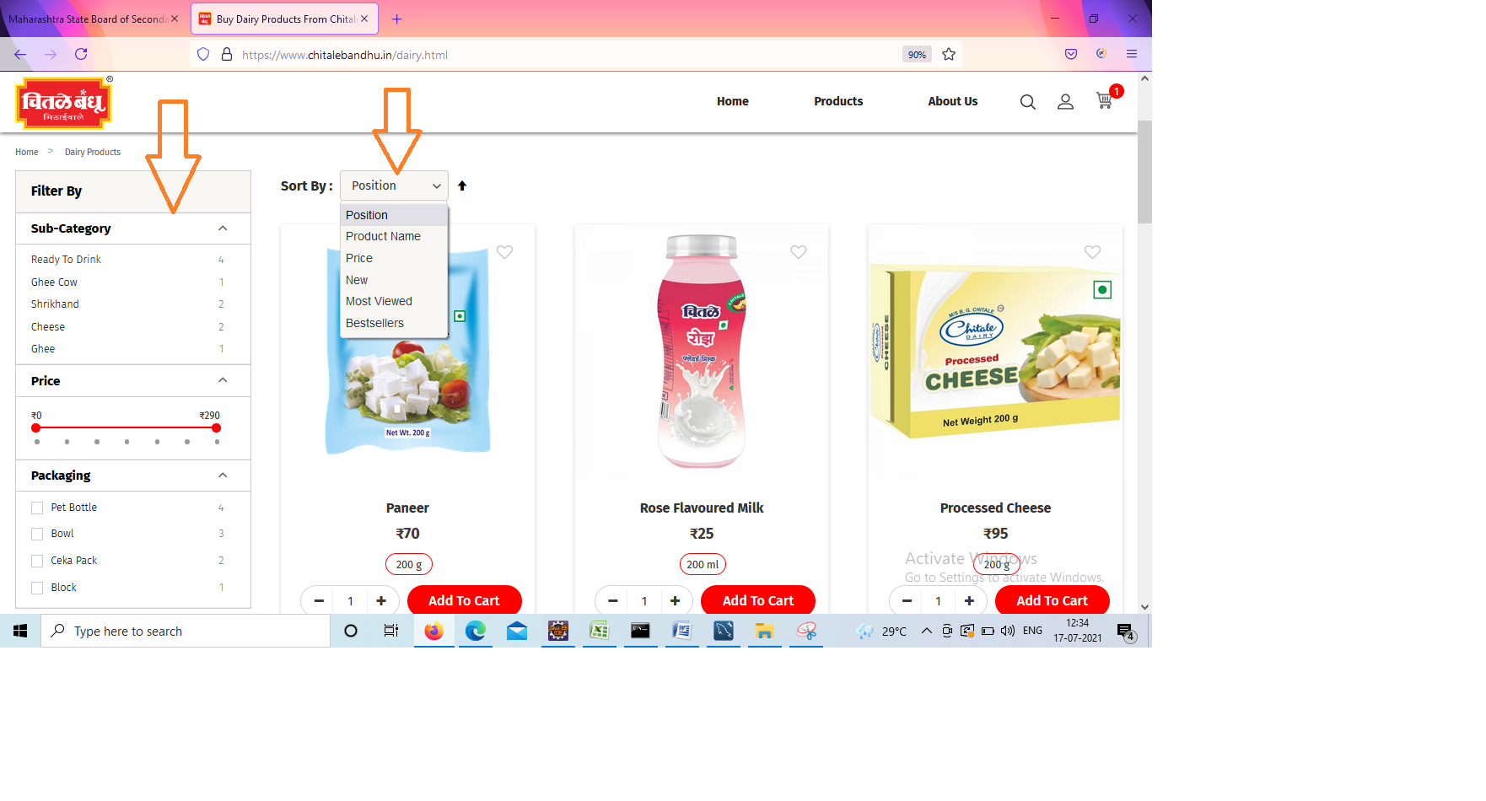

**TC24-To check the functionality Of add to cart products**

w.findElement(By.*xpath*("/html/body/div[2]/main/div[2]/div[1]/div[6]/ol/li[1]/div/div[3]/div[4]/div/div/form/div[2]/div/button")).click();

w.findElement(By.*xpath*("/html/body/div[2]/header/div[2]/div[1]/a")).click();

Thread.*sleep*(3000);

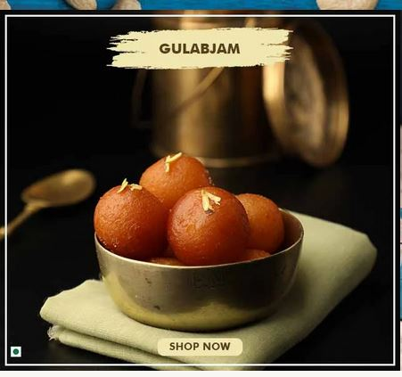

**TC25-To check the functionality of View cart products**

w.findElement(By.*xpath*("/html/body/div[2]/header/div[2]/div[1]/div/div/div/div[2]/div[3]/div[2]/a/span/span")).click();

System.***out***.println("view cart");

Thread.*sleep*(3000);

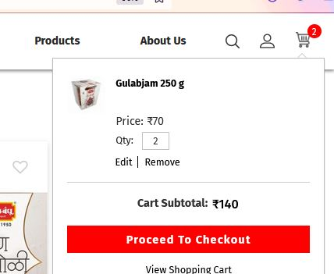

**TC26-To check the functionality of add ‘+’ Product**

w.findElement(By.*xpath*("/html/body/div[2]/main/div[3]/div/div[4]/form/div[1]/table/tbody/tr/td[3]/div/div/span[2]")).click();

Thread.*sleep*(3000);

w.findElement(By.*xpath*("/html/body/div[2]/main/div[3]/div/div[4]/form/div[1]/table/tbody/tr/td[3]/div/div/span[2]")).click();

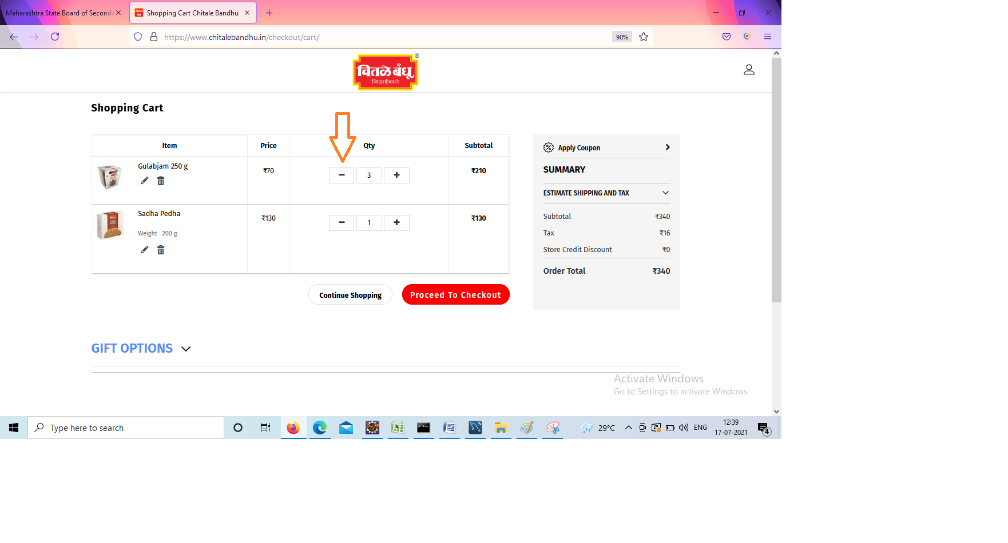

**TC27-To check the functionality of ‘-’Product**

w.findElement(By.*xpath*("/html/body/div[2]/main/div[3]/div/div[4]/form/div[1]/table/tbody/tr/td[3]/div/div/span[1]")).click();

w.findElement(By.*xpath*("//div[@class='checkout-button-wrapper']//button[@type='button']")).click();

System.***out***.println("add more products and less products");

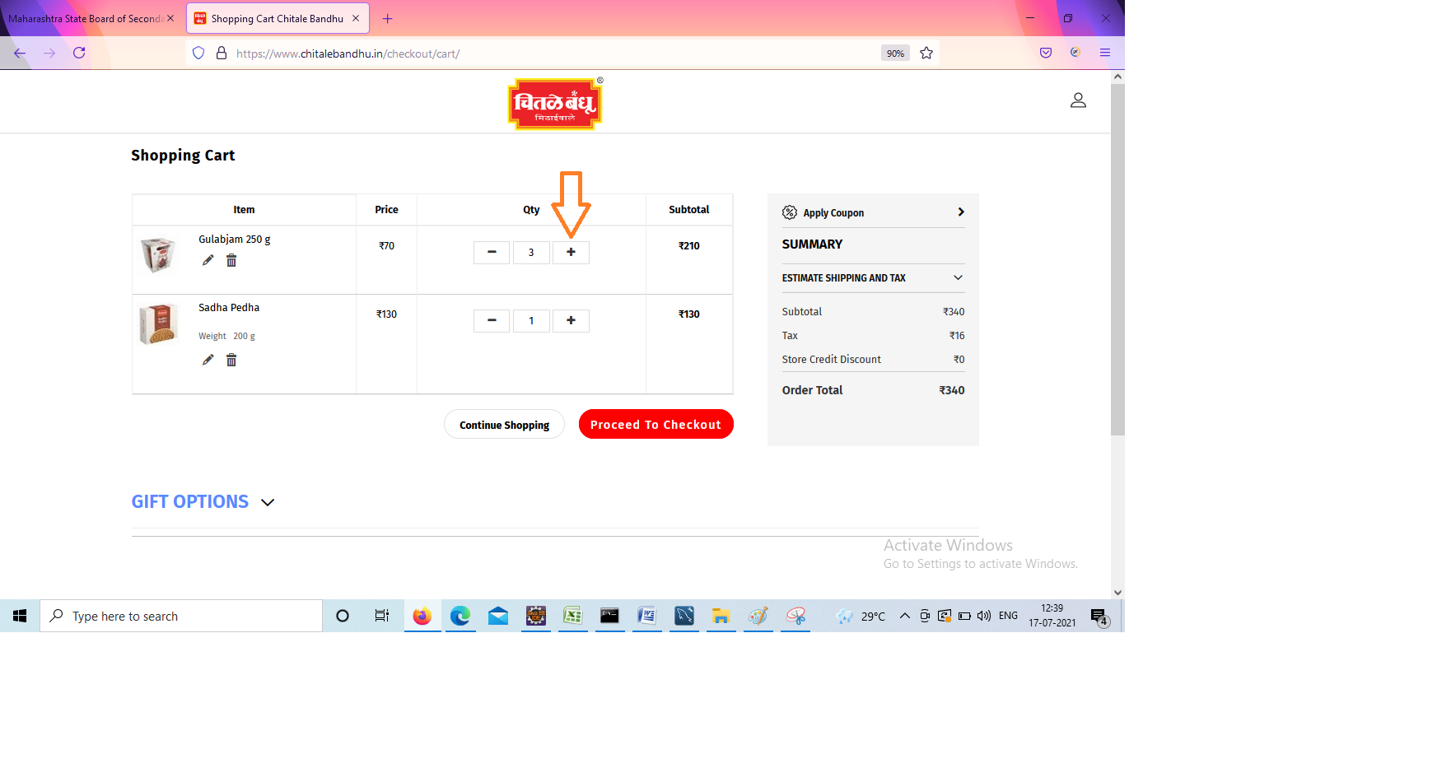

**TC28-To check the functionality of Checkout Product**

w.findElement(By.*xpath*("//div[@class='checkout-button-wrapper']//button[@type='button']")).click();

System.***out***.println("checkout");

Thread.*sleep*(3000);

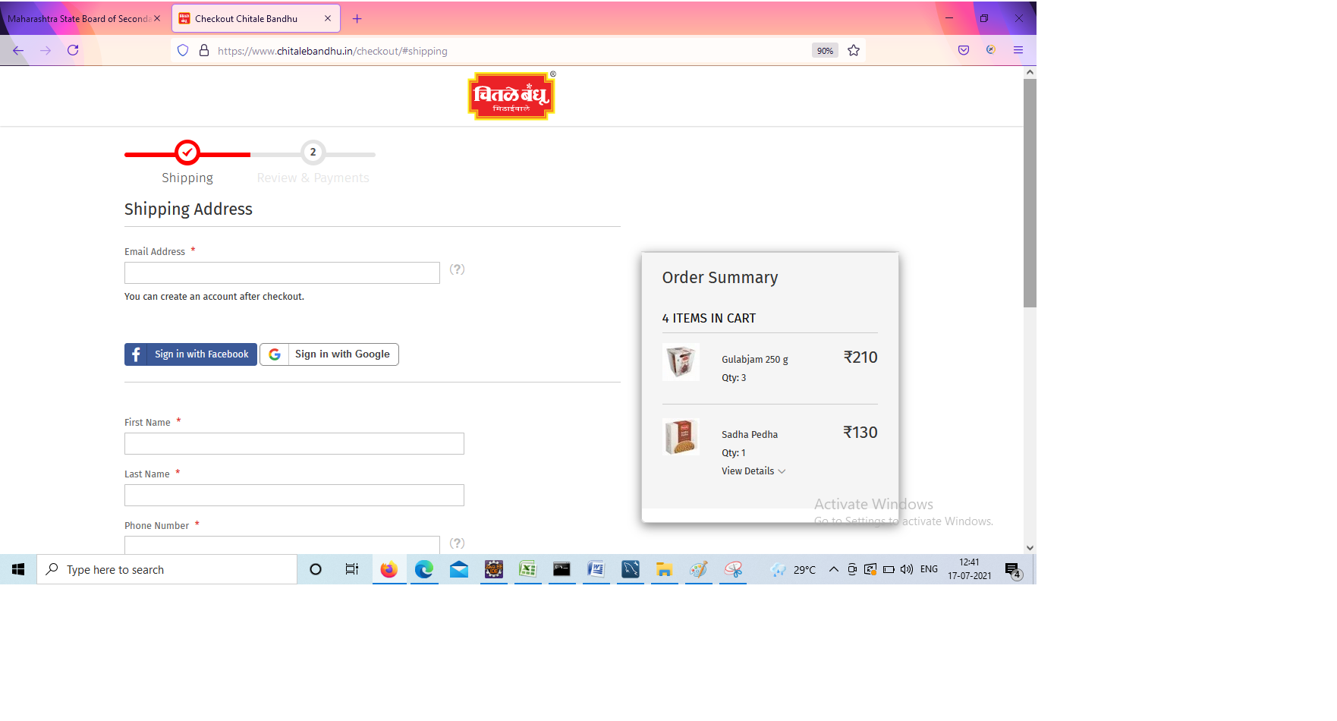 w.navigate().back();

Defects:

1. Distributor location: Pune

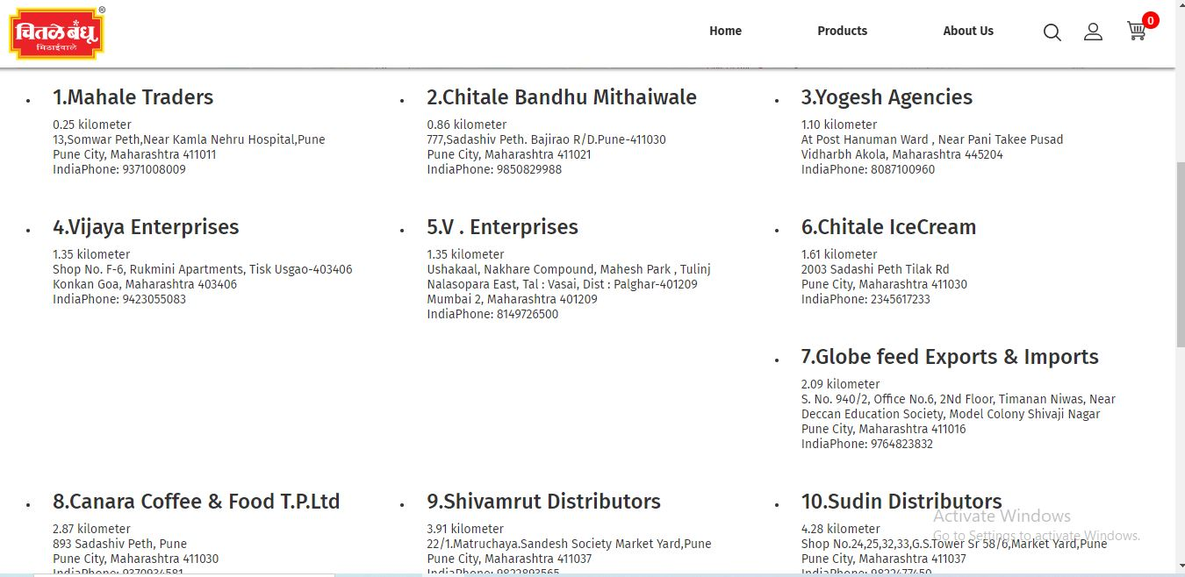

1. **Store locator:**

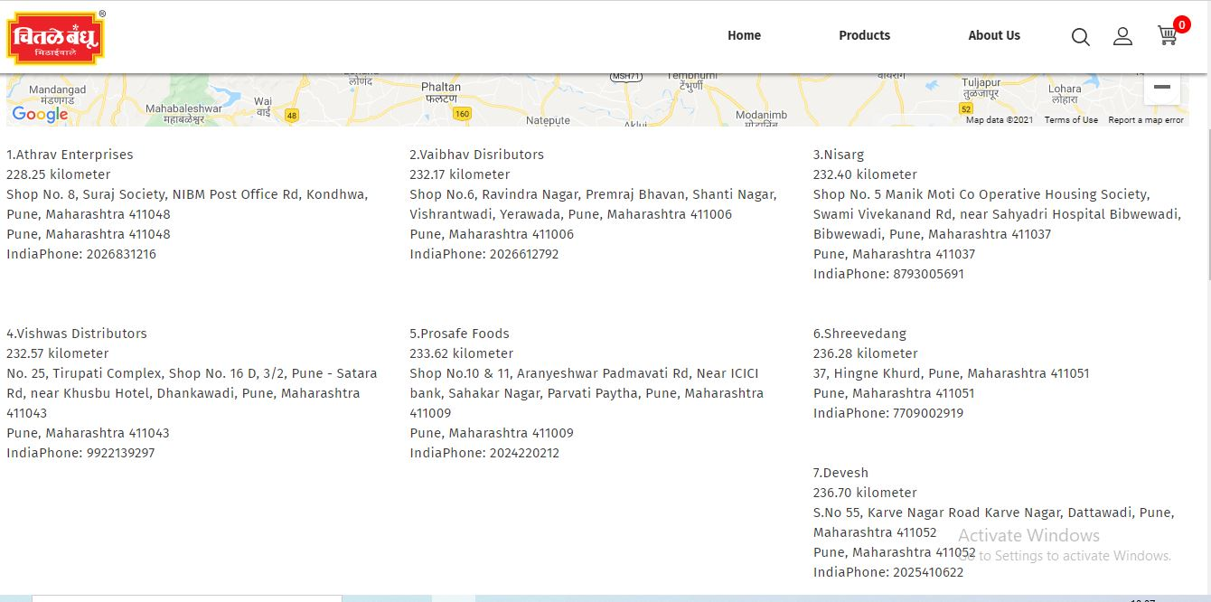

**3.**

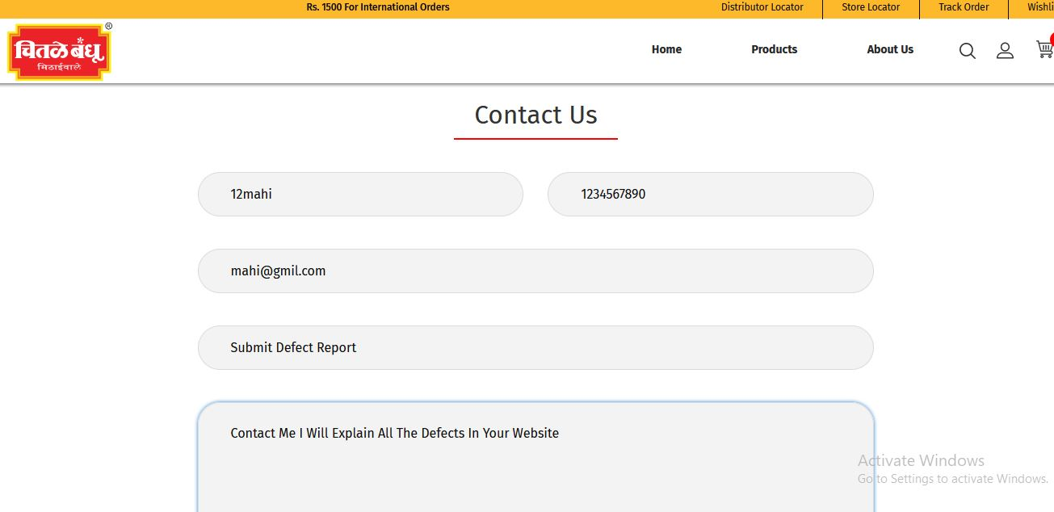

**4.**

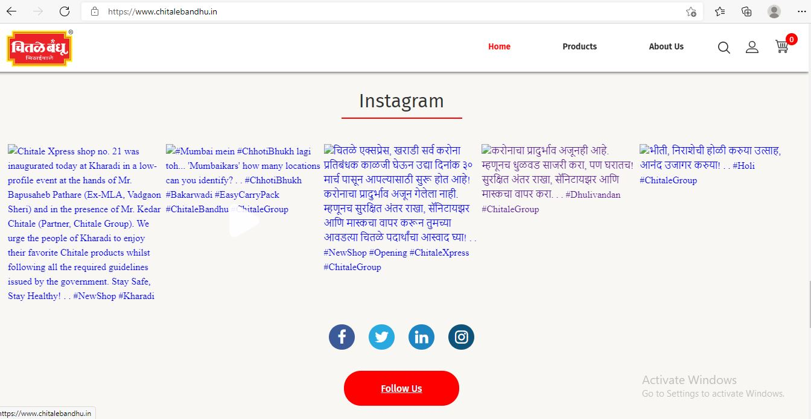

**5. Zoom IN**

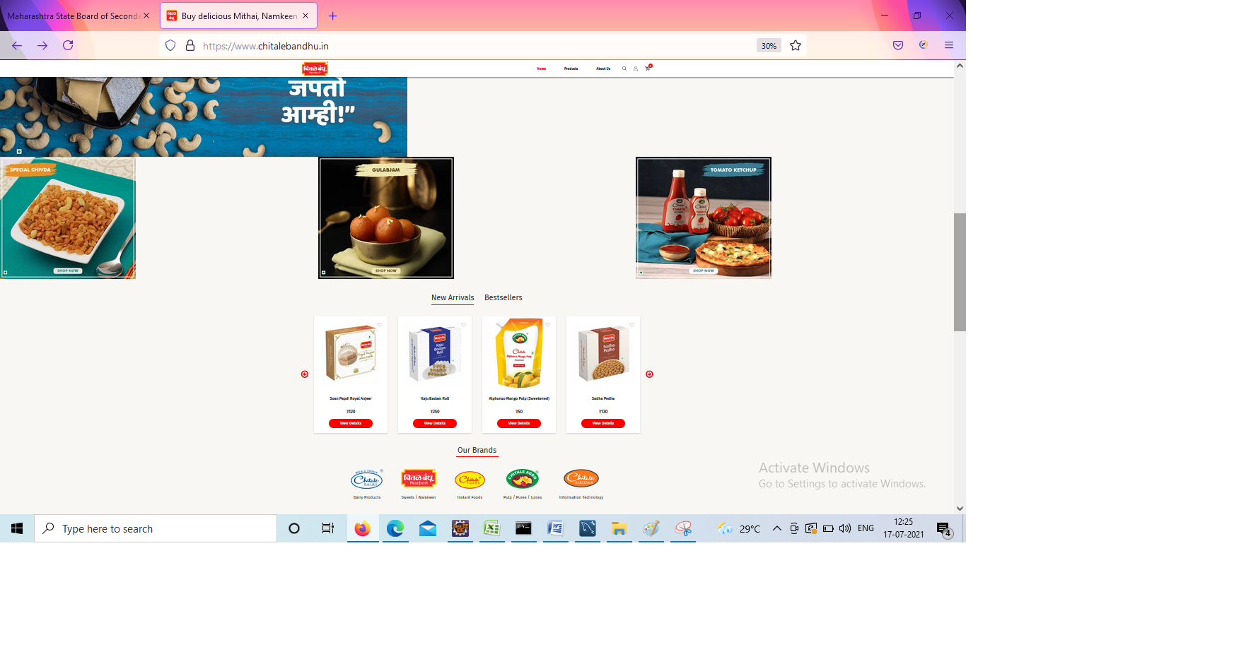

**6.**

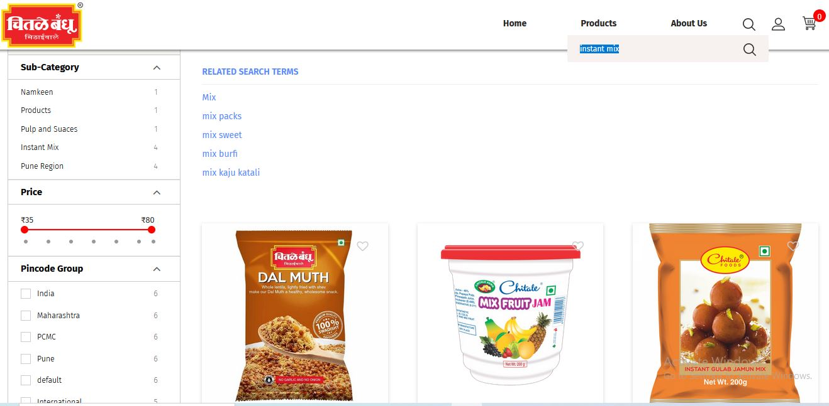

**7.**

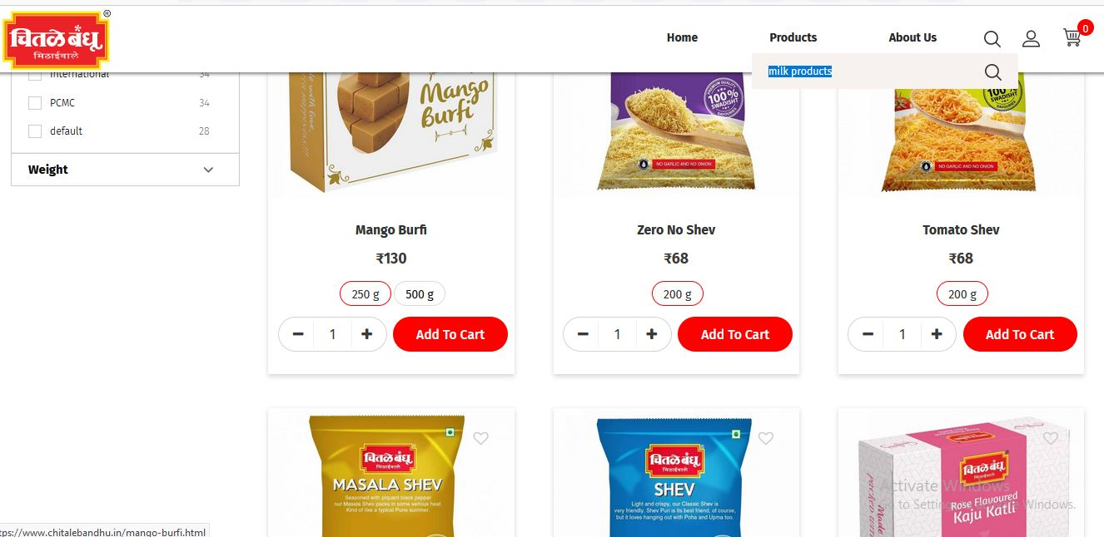

**8.**

